**Tournament management system**

**Name**: Syed QAIM RAZA Kazmi

* **Short Description of your project**

This is tournament system which have an Admin (Tournament manager) and a player(users). First, of all we have a team registration, team add and then we login as an admin and team(user) then you select the game which we have either cricket, football, chess, badminton then we add how many players you want add in a team so same again in all games. Team can remove any player and admin can remove team not any team member. The team players have been sorted in players manner such as batsman, All Rounder, bowler. This is the tournament management system.

* **Users of Application**

Two user one is admin (Tournament manager) and other is the team(user)

* **Functional Requirements**

1.Team registration

2.login as team and admin

3.select game

3.Add team

4.Add player

5.only admin can view

6.view record

7.Game schedule

8.Complain cell

9. Admin can delete the team

* **Wireframes**

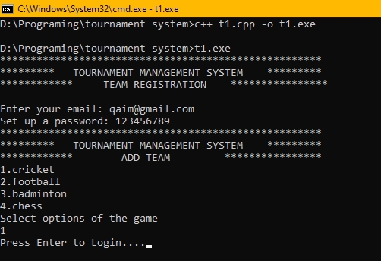

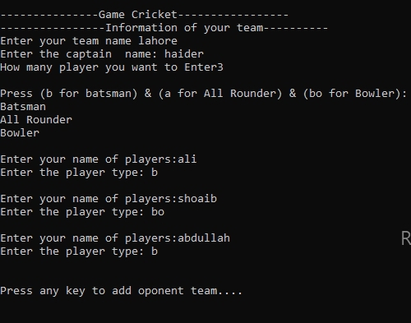

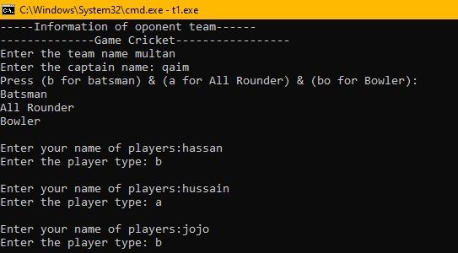

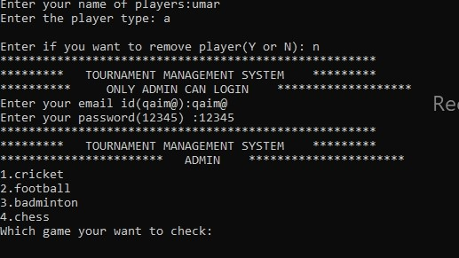

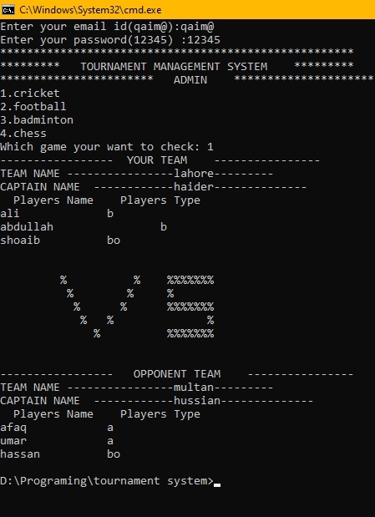

**IF we want to remove player so:**

**The player “Shoaib” has been removed**

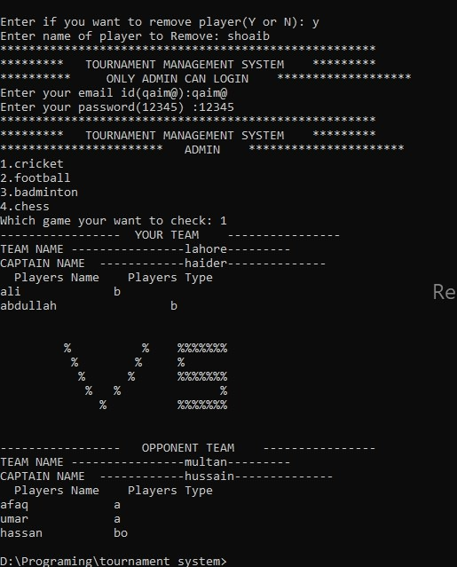

* **Data Structures**

string opteamname; // (opt mean opponent)

string teamname;

string opentname; // (foot mean football)

string name;

string footteamname;

string footopteamname;

int howmanyplayer;

int yes = false;

int count = 0;

const int arraysize = 11;

* **Functions Prototypes**

void menu();

void checkpassdigit(string passwort);

void checkmail(string emails);

int selectgame();

int admincheck();

void playertype();

void vsdisplay();

void display(string criteamname, string playername[9], string playerfield[9]);

void displayplname();

void displayfootballtype();

void storedata();

void storedatafootball();

void load_datacricket();

void load_datafootball();

string s_name[arraysize];

string s_field[arraysize];

string s_optname[arraysize];

string s_optfield[arraysize];

string s_footname[arraysize];

string s_footfield[arraysize];

string s_footoptname[arraysize];

string s_footoptfield[arraysize];

* **Functions Working Flow**

**Main( )**

Admin

(tournament manger)

Team Registration

LOGIN AS

ADMIN

TEAM

LOGIN

ADD

PLAYER

Delete team

REMOVE

PLAYER

View player

* **Complete Code (Every code section contain a its wireframe**

main()

{

// load_datacricket();

string password = " ";

string logpassword = " ";

string email = " ", logemail = " ";

menu();

cout << "************ TEAM REGISTRATION ***************" << endl;

cout << "Enter the email: ";

cin >> email;

cout << "Set up a password: ";

cin >> password;

// checkmail(email);

checkpassdigit(password);

if (count > 7)

{

menu();

cout << "************ ADD TEAM ***************" << endl;

int option = selectgame();

cout << "Press any key to Login....";

getch();

system("cls");

menu();

int opti;

cout << "1.Login as a cricket team " << endl;

cout << "2.Login as a football team " << endl;

cout << "3.Login as an admin " << endl;

cout << "Select one of the option: " << endl;

cin >> opti;

// This is a way to login as a admin and a team

// cout << endl;

//

// this is the login password and id

if (opti == 3)

{

menu();

cout << "********** ONLY ADMIN CAN LOGIN *******************" << endl;

// this is the login password and id

while (logemail != "qaim@" || logpassword != "12345")

{

cout << "Enter your email id(qaim@):";

cin >> logemail;

cout << "Enter your password(12345) :";

cin >> logpassword;



\

if (logemail == "qaim@" && logpassword == "12345")

{

menu();

cout << "*********************** ADMIN **********************" << endl;

int options = admincheck();

if (options == 1)

{

cout << "----------------- YOUR TEAM ----------------" << endl;

cout << "TEAM NAME ----------------" << teamname << "---------" << endl;

cout << "CAPTAIN NAME ------------" << name << "--------------" << endl;

displayplname();

// sorting batsman

for (int c = 0; c < howmanyplayer; c++)

{

if (playerfield[c] == "b")

{

cout << playername[c] << "\t \t" << playerfield[c] << endl;

}

}

// soring for allrounder

for (int d = 0; d < howmanyplayer; d++)

{

if (playerfield[d] == "a")

{

cout << playername[d] << "\t \t" << playerfield[d] << endl;

}

}

// sorting for bowler

for (int e = 0; e < howmanyplayer; e++)

{

if (playerfield[e] == "bo")

{

cout << playername[e] << "\t \t" << playerfield[e] << endl;

}

}



cout << "-----Information of oponent team------" << endl;

cout << "--------------Game Cricket-----------------" << endl;

cout << "Enter the team name ";

cin >> opteamname;

cout << "Enter the captain name: ";

cin >> opentname;

playertype();

cout << endl;

for (int opent = 0; opent < howmanyplayer; opent++)

{

cout << "Enter your name of players:";

cin >> opentplayername[opent];

cout << "Enter the player type: ";

cin >> opentplayerfield[opent];

cout << endl;

storedata();

}



menu();

cout << "********** ONLY ADMIN CAN LOGIN *******************" << endl;

// this is the login password and id

cout << "Enter your email id(qaim@):";

cin >> logemail;

cout << "Enter your password(12345) :";

cin >> logpassword;

if (logemail == "qaim@" && logpassword == "12345")

{

menu();

cout << "*********************** ADMIN **********************" << endl;

int options = admincheck();

if (options == 1)

{

cout << "----------------- YOUR TEAM ----------------" << endl;

cout << "TEAM NAME ----------------" << teamname << "---------" << endl;

cout << "CAPTAIN NAME ------------" << name << "--------------" << endl;

displayplname();

// this is the sorting

// sorting batsman

for (int c = 0; c < howmanyplayer; c++)

{

if (playerfield[c] == "b")

{

cout << playername[c] << "\t \t" << playerfield[c] << endl;

}

}

// soring for allrounder

for (int d = 0; d < howmanyplayer; d++)

{

if (playerfield[d] == "a")

{

cout << playername[d] << "\t \t" << playerfield[d] << endl;

}

}

// sorting for bowler

for (int e = 0; e < howmanyplayer; e++)

{

if (playerfield[e] == "bo")

{

cout << playername[e] << "\t \t" << playerfield[e] << endl;

}

}

// end sorting

}

// sorting for the opponent team

vsdiaplay();

cout << "----------------- OPPONENT TEAM ----------------" << endl;

cout << "TEAM NAME ----------------" << opteamname << "---------" << endl;

cout << "CAPTAIN NAME ------------" << opentname << "--------------" << endl;

displayplname();

for (int t = 0; t < howmanyplayer; t++)

{

if (opentplayerfield[t] == "b")

{

cout << opentplayername[t] << "\t \t" << opentplayerfield[t] << endl;

}

}

// soring for allrounder

for (int n = 0; n < howmanyplayer; n++)

{

if (opentplayerfield[n] == "a")

{

cout << opentplayername[n] << "\t \t" << opentplayerfield[n] << endl;

}

}

// sorting for bowler

for (int p = 0; p < howmanyplayer; p++)

{

if (opentplayerfield[p] == "bo")

{

cout << opentplayername[p] << "\t \t" << opentplayerfield[p] << endl;

}

}

}

}



if (yesno == 'y')

{

cout << "How many player you want to remove ";

cin >> value;

string nameofplayer;

for (int r1 = 1; r1 <= value; r1++)

{

cout << "--" << r1 << "--"

<< "Enter name of player to Remove: " << endl;

cin >> nameofplayer;

for (int i = 0; i < howmanyplayer; i++)

{

if (playername[i] == nameofplayer)

{

playername[i] = ' ';

playerfield[i] = ' ';

}

else if (opentplayername[i] == nameofplayer)

{

opentplayername[i] = ' ';

opentplayerfield[i] = ' ';

}

}

}

}

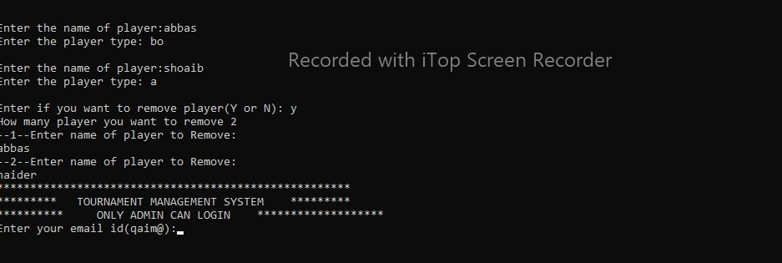

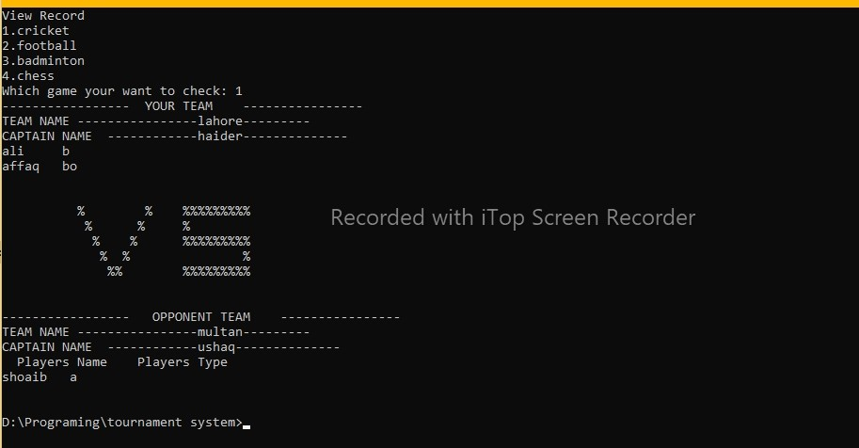

|  |  |  |  |  |
| --- | --- | --- | --- | --- |
|  | | | | |
|  |  |  |  |  |
|  | | | | |
|  |  |  |  |  |
|  |  |  |  |  |
|  | | | | |
|  |  |  |  |  |
|  |  |  |  |  |
|  |  |  |  |  |
|  |  |  |  |  |
|  | | | | |
|  |  |  |  |  |
|  |  |  |  |  |
|  |  |  |  |  |
|  |  |  |  |  |

|  |  |  |  |  |
| --- | --- | --- | --- | --- |
|  |  |  |  |  |
|  |  |  |  |  |
|  | | | | |
|  |  |  |  |  |
|  | | | | |
|  |  |  |  |  |
|  |  |  |  |  |
|  | | | | |
|  |  |  |  |  |
|  |  |  |  |  |
|  |  |  |  |  |
|  | | | | |
|  |  |  |  |  |
|  |  |  |  |  |
|  |  |  |  |  |
|  |  |  |  |  |

|  |  |
| --- | --- |
| **Checked by:** | Click or tap here to enter text. |